# ERP Application – Townhall Presentation Report

## Project Overview & Achievements:

ERP Dashboard Application – React.js, Node.js

1. User authentication implemented (username & password login)
2. Role-based dashboard view completed
3. Resume submission and User management workflow completed
4. Bench Sales workflow completed
5. Accounting, Onboarding and Timesheets workflows in progress
6. Deployed live at: <https://prophechyerp.duckdns.org/dashboard>

## Modules:

* Resume Submission Module
* Recruitment Module
* Bench Sales Module
* User Management Module
* Accounting Module

## Recruitment Module:

* **Role Management**: Create, view, edit, and delete job roles with detailed specifications
* **Candidate Applications**: Submit, track, and manage candidate applications with resumes
* **Hiring Process Workflow**: Visual pipeline showing application progress through multiple stages
* **Multi-role Support**: Different views and permissions for managers, team leads and recruiters
* **File Management**: Resume upload, viewing, and management system
* **Advanced Filtering**: Search and filter roles by various criteria

**Screenshots:**

**Admin View**

**Manager View:**

**Team lead View:**

**Recruiter view:**

**User Management Module:**

* **CRUD Operations:** Create, view, edit, and delete user accounts.
* **Search & Filters:** Find users by name, email, role, or status.
* **Role Control:** Assign roles (Admin, Manager, Recruiter, etc.) to control system access.
* **Profile Management:** Store user details like name, email, and phone number.
* **Password Management:** Set and reset user passwords securely.
* **Clean UI:** Modern, responsive interface with clear visual cues for roles and status.

**Screenshots:**

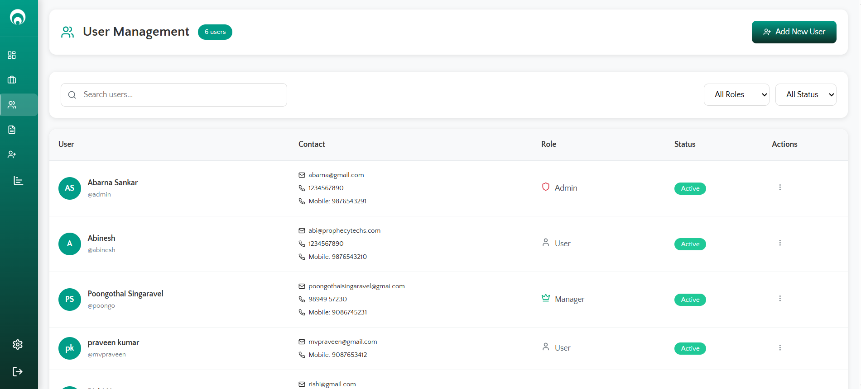

## Bench Sales Module:

* Bench Sales Dashboard for tracking consultants
* Candidate Management for maintaining consultant profiles
* Requirements management to map client needs
* Submissions tracking with client feedback
* Vendor management system
* Marketing tools integrated
* Hotlist for active consultant profiles

## Bench Sales Module – Screenshots:

## Next Plan & Enhancements:

* Complete advanced reporting & analytics
* Integration with external job portals
* Implement AI-powered Resume Parser
* Enhance UI/UX with feedback from users
* Connect Resume Parser to Recruitment Module for instant profile matching against new roles
* Add advanced filters: search location preferences, rate range, and skills